Project Title: Kurima - Embracing the Transformation of Rural Economies in Angola
Project Number: -
Implementing Partner: United Nations Development Program
Start Date: March 2026 End Date: March 2027
PAC Meeting date: …..

Brief Description
Kurima – Embracing the Transformation of Rural Economies in Angola is a 12-month initiative that aims to expand youth employment and strengthen rural livelihoods along Angola’s Lobito Corridor. Building on the results of the Kurima pilot, the initiative focuses on increasing access to digital agriculture solutions, clean energy, and market-oriented services for youth- and women-led cooperatives in Benguela Province.
Drawing on expertise in precision agriculture, including drones, satellite-based monitoring, climate data, and the KAIZEN continuous improvement approach, Kurima supports the adoption of climate-smart and market-responsive production practices. These inputs are delivered through a targeted package of skills development, technology deployment, enterprise support, and bilateral knowledge exchange, contributing to productivity gains, stronger value-chain participation, and the creation of decent green livelihood opportunities for young people.
Over the project period, Kurima will train 400 youth and women in digital agriculture and agribusiness, provide grant and mentorship support to 10 youth-led enterprises, and enable five cooperatives to pilot advanced agri-technology solutions. UNDP will proactively seek opportunities to engage Japanese technologies and/or Japanese companies, where appropriate and feasible, through piloting, technical cooperation, and partnership arrangements that support project outcomes.
The initiative reinforces Angola–Japan cooperation in line with TICAD9, the SDGs, and Angola’s National Development Plan, while addressing key gaps in youth employability, technology access, and market linkages through catalytic JSB support. Strategic alignment with ongoing and planned public–private partnership investments in the Lobito Corridor will further enhance connectivity, sustainability, and potential for scale.

Contributing Outcome (UNSDCF, CPD, RPD):  Outcome 3: By 2028, more people, especially women, youth and the most vulnerable, participate in and benefit from more inclusive, diversified and sustainable economic growth  Indicative Output(s) with gender marker: GEN2 |  | Total resources required: | $246,666
 |  | Total resources allocated:
 |  | Total resources allocated: | UNDP :
 |  | Total resources allocated: | Government of Japan: | $246,666
 |  | Total resources allocated: | In-Kind:
 |  | Unfunded:

Agreed by (signatures):
Government of Japan | UNDP
Print Name: …….. | Print Name: Denise Antonio
Date: | Date:

Development Challenge (1/4 page – 2 pages recommended)
Angola has recorded its strongest economic performance in recent years, with real GDP growth reaching 4.4% in 2024, driven primarily by the non-oil sector. Agriculture and fisheries now contribute 14.9% of GDP—more than doubling their share since 2010—reflecting sustained national efforts to diversify the economy away from oil dependence. However, Angola remains highly vulnerable to external shocks, including fluctuations in global oil prices and increasing climate-related risks such as droughts and erratic rainfall, and economic growth has yet to translate into sufficient employment opportunities, particularly for youth and women.
Angola’s demographic profile presents both a significant opportunity and a pressing challenge. With a population of 36.6 million, of which 64% is under 25, the country is entering a critical demographic window. Yet unemployment remains high at 30.4%, with youth accounting for over half of the unemployed population. Informality dominates the labour market, especially among youth (92%) and women (88%), limiting access to decent work, income security, and social protection. The social unrest experienced in 2025 underscored the urgency of addressing youth unemployment, food insecurity, and rural poverty through integrated and forward-looking solutions.
Strategic Role of Agriculture and the Lobito Corridor
Agriculture is central to Angola’s long-term development strategy and economic diversification. Despite having 35 million hectares of arable land, only 10% is currently cultivated, and productivity remains constrained by low mechanization, limited digitalization, weak market linkages, and insufficient investment in innovation and skills. The Government’s National Development Plan (2023–2027) prioritizes increased national production, employment creation, and human capital development, supported by flagship initiatives including PLANAGRÃO, PLANAPECUÁRIA, PLANAPESCA, and PRODESI.
The Lobito Corridor offers a transformative opportunity to operationalize these ambitions. By connecting fertile yet underserved provinces—Benguela, Huambo, Bié, Moxico, and Moxico Leste—to regional and global markets, the Corridor can unlock export-oriented agriculture, stimulate private investment, and generate rural employment. However, without targeted investments in youth skills, digital tools, and enterprise development, these opportunities risk bypassing rural communities and exacerbating inequality.
The Kurima Scale-Up: An Innovation-Led Response
Building on the success of the Kurima pilot, which demonstrated measurable gains in productivity, gender inclusion, and access to clean energy and irrigation, the Kurima Scale-Up proposes an integrated, innovation-led approach to rural transformation. The project will empower youth and women through advanced AgriTech solutions, including satellite data, drones, precision agriculture tools, and digital business platforms, combined with targeted skills development and enterprise support.
The initiative complements Angola’s ambition to establish a Timbuktoo Regional AgriTech Hub, ensuring that national innovation ecosystems deliver tangible benefits at the rural and community levels. By embedding technology within local value chains, the project will reposition agriculture as a modern, viable, and aspirational career pathway for young people.
Strategic Partnerships and TICAD Alignment
The project pursues to integrate Japanese expertise through clearly defined technical, operational, and partnership mechanisms aligned with the objectives of TICAD 9 and the JSB framework. Japanese knowledge and technologies are not referenced in principle only, but are embedded in implementation, capacity building, and scale-up pathways. UNDP will seek opportunities to engage Japanese private-sector technology providers and other Japanese stakeholders through collaboration, piloting, and technical partnerships, as appropriate and feasible during implementation.
First, precision agriculture technologies originating from Japan—including drone-based crop surveillance, satellite-enabled climate and soil monitoring, and data-driven advisory systems—will be adapted for smallholder and corridor-based farming systems. These technologies will be applied to improve yield forecasting, optimize input use, and strengthen climate resilience. The project will seek opportunities to engage Japanese private-sector technology providers with experience in deploying precision agriculture solutions in emerging markets, including through pilot initiatives, technical cooperation, and knowledge exchange during implementation.
Second, Japanese KAIZEN methodologies will be applied at both farm and agribusiness levels to improve operational efficiency, reduce post-harvest losses, and strengthen cooperative and SME management. KAIZEN tools will be localized and delivered through structured training-of-trainers approaches, enabling farmer organizations and agri-enterprises along the Lobito Corridor to institutionalize continuous improvement practices rather than rely on one-off interventions.
Third, institutional and capacity-building support will be pursued through partnerships with Japanese stakeholders such as JICA, Japanese agribusiness firms, relevant Japanese NGOs, and academic or research institutions. The project will seek opportunities to catalyze partnerships with Japanese stakeholders, including private-sector technology providers, to strengthen technology transfer, skills development, and policy-relevant learning by leveraging globally benchmarked standards and implementation experience.
Finally, the JSB catalytic grant approach supports the piloting, validation, and early adoption of Japanese technologies and practices by reducing initial implementation risks. Successful models will be leveraged through the TICAD platform to attract follow-on private investment and enable replication across the Lobito Corridor and other regions, reinforcing sustained Angola–Japan cooperation and long-term development impact.

Expected Results and Development Impact
The Kurima initiative will:
- 100 farmers in five cooperatives improve productivity and resilience through the adoption of digital and climate-smart agriculture tools
- 400 youth and women trained, of whom 120 are engaged in income-generating activities..
- 3–5 Japanese technologies and/or practices engaged, adapted, and/or piloted through collaboration with Japanese stakeholders, where appropriate and feasible
- 60% of beneficiaries report improved productivity or resilience

Fully aligned with TICAD priorities, Agenda 2063, regional and continental frameworks such as the AfCFTA, and Angola’s national strategies, the project addresses systemic barriers such as informality, climate vulnerability, and digital exclusion. By equipping the next generation—especially youth and women—with skills, technologies, and market access, the Kurima Scale-Up will help transform Angola’s demographic potential into a driver of inclusive, resilient, and sustainable growth.

Strategy (1/2 page - 3 pages recommended)

The Kurima Initiative is designed as a human security–oriented intervention that addresses the interlinked risks of youth unemployment, livelihood vulnerability, and climate-related instability in rural Angola. By strengthening productive capacities and creating dignified employment opportunities in the agrifood sector, the initiative contributes to the prevention of livelihood shocks, youth disaffection, and social fragility, particularly in climate-exposed rural communities.
Through the deployment of climate-smart technologies, precision agriculture, and targeted support to youth- and women-led agribusinesses, Kurima enhances household and community resilience to economic and environmental stresses. Its focus on skills development, enterprise creation, and market integration ensures that growth translates into sustainable livelihoods rather than short-term gains.
Anchored in the Lobito Corridor, where economic transformation and climate exposure intersect, the initiative aligns employment generation with resilience-building, ensuring that infrastructure-led growth is matched by inclusive, people-centred outcomes. By embedding innovation, private-sector engagement, and Japan-supported operational excellence, Kurima advances JSB’s human security objectives by reducing vulnerability while expanding opportunity.

The Theory of Change (ToC)

The Kurima Initiative Theory of Change sets out how, within a 12-month timeframe, the project will deliver concrete outputs—such as skills training, deployment of selected agri-technologies, and support to youth-led enterprises—that are expected to contribute to short-term outcomes including improved productivity practices, enhanced employability of youth and women, and strengthened capacity to manage climate-related risks.
In line with the ToC, the proposed outcomes are as follows:

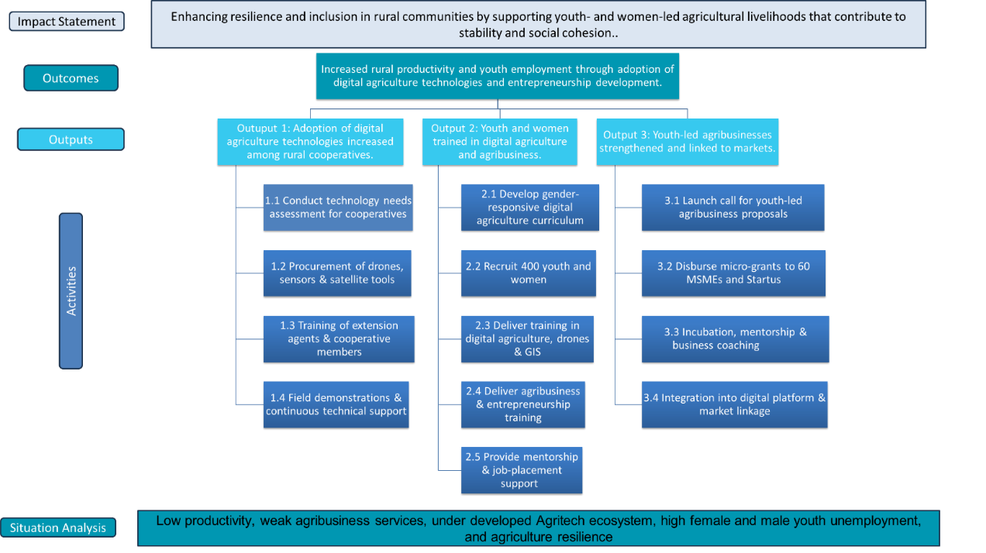

Results and Partnerships
Expected Results
The Kurima project is expected to generate transformative outcomes at multiple levels. By introducing satellite and drone technologies, it will improve agricultural productivity and climate resilience in five pilot cooperatives. The project will also seek to catalyze partnerships between Angolan institutions and Japanese technology providers, strengthening bilateral innovation and knowledge exchange. Collectively, these results will contribute to food security, job creation, and scalable models for digital agriculture in Angola. The project will provide targeted training to agricultural extension agents and cooperative members to strengthen their capacity to deliver and apply digital agriculture solutions, climate-smart practices, and basic agribusiness services. Training will focus on practical, hands-on learning to support technology uptake, improve advisory services, and ensure sustained use of innovations at community level beyond the project period. The following results have been adopted:
Result 1: Increased adoption of digital agriculture technologies (e.g., drones and satellite monitoring) by 100 smallholder farmers, primarily through cooperative-based service models.
Result 2: 400 youth and women acquire practical skills in digital agriculture, agri-entrepreneurship, and climate-smart practices, improving employability and readiness for agribusiness opportunities.
Result 3: Improved market access and initial formalization of a targeted number of youth-led agricultural businesses through linkages to buyers, cooperatives, and service providers.
Result 4: Strengthened Angola–Japan cooperation through practical technology transfer, applied training, and innovation exchange involving Japanese private sector, JICA, and local counterparts.
Result 5: A robust monitoring, evaluation, and learning (MEL) system established to ensure accountability, capture lessons, and inform potential scale-up and replication beyond the project period.
Please note that target values may be subject to slight adjustment after the project commences to ensure achievement of the intended outcomes.

Risks and Assumptions
The framework below identifies key risks and assumptions affecting the implementation of the project and outlines corresponding mitigation measures aligned with the project’s Theory of Change, outputs, and management arrangements.
  - Risk Identification and Assessment Table
Risk Category | Description | Likelihood | Impact | Mitigation Strategy
Institutional and Coordination | Limited coordination among government, private sector, and development partners may slow decision-making and delay implementation of multi-stakeholder activities. | Medium | High | Use the existing Project Steering Committee (PSC) and coordination mechanism, co-chaired by the Minister of State for Economic Coordination and UNDP, to provide strategic oversight, supported by regular coordination meetings and progress reviews with clear reporting lines.
Financial and Resource Mobilization | Delays or shortfalls in securing co-financing from Government, timbuktoo Initaitive , or partners could affect project scope and sustainability, Limited investor appetite | Medium | High | Develop a Resource Mobilization Plan early in the project; Diversify funding sources; Engage potential co-financing partners (DFIs, private investors) through the partnership framework; Maintain transparent financial tracking and reporting.
Technological and Infrastructure | Challenges in deploying or maintaining the digital platform due to limited internet coverage, data management capacity, or cybersecurity risks; resistance to new technologies | Medium | High | Partner with telecom operators and fintechs for connectivity solutions; Ensure cybersecurity protocols are embedded in the platform design; Build local technical capacity for maintenance and user support.
Policy or institutional delays | Delays in approval of enabling policies or digital regulations may hinder implementation of AgriTech and e-commerce solutions. | Medium | Medium | Engage with MinPlan, MAPTSS, and MESCTI to fast-track policy dialogues and draft digital frameworks; Use the Technical Working Group to support policy harmonization.
Operational / Capacity Risk | SMEs and startups may not possess the necessary technical, digital, or business skills to adopt AgriTech solutions, meet certification and export requirements, or effectively participate in innovation processes | Medium | High | Provide tailored technical assistance, mentorship, and business development training; develop practical learning labs; partner with universities and innovation hubs for capacity-building;
Stakeholder Engagement
A participatory, multi-stakeholder approach will engage government, academia, the private sector, development partners, youth innovators, SMEs, and communities in shaping and implementing interventions. MESCTI and line ministries will lead policy alignment and coordination; universities and incubators will support research and talent development; private sector partners will provide digital solutions, co-investment, and market access; and CSOs will ensure the inclusion of youth, women, and vulnerable groups. Engagement will be delivered through consultations, co-creation workshops, advisory groups, user testing, and participatory monitoring, supported by an accessible and transparent Grievance Redress Mechanism that allows beneficiaries and stakeholders to raise concerns, provide feedback, and seek timely resolution, thereby reinforcing accountability, social cohesion, and alignment with JSB’s human security and safeguard principles.
Knowledge Management and Dissemination
A dedicated Knowledge Management Strategy will capture and share evidence and lessons learned through success stories, inclusion insights, policy briefs, prototype case studies, and innovation profiles.

Project Management
Implementation of Kurima – Embracing the Transformation of Rural Economies will follow UNDP’s Direct Implementation Modality (DIM) and results-based management standards to ensure strong Government ownership, effective coordination with Japanese partners, and timely delivery over the 12-month period (March 2026–February 2027).
A Project Steering Committee (PSC) will provide strategic oversight, ensure alignment with Angola’s National Development Plan (2023–2027), the Lobito Corridor agenda, and TICAD9 priorities, and address high-level bottlenecks. Co-chaired by the Minister of State for Economic Coordination and UNDP, the PSC will include MINAGRIF, the Ministries of Youth and Sports and Social Action/Family/Women’s Empowerment, the Provincial Government of Benguela, relevant local administrations, UNDP programme and operations teams, and Japanese partners (Embassy of Japan/JICA) in an advisory role. The PSC will meet quarterly to approve workplans and key deliverables.

A Technical Working Group (TWG) will meet monthly to coordinate technology deployment, training, enterprise support, and partnerships.

Results Framework
Intended Outcome as stated in the UNSDCF/Country Angola Programme Results and Resource Framework: Outcome 3: By 2028, more people, especially women, youth and the most vulnerable, participate in and benefit from more inclusive, diversified and sustainable economic growth

Outcome indicators as stated in the Country Programme [or Regional] Results and Resources Framework, including baseline and targets: Output 1.1. Inclusive and sustainable solutions adopted for enhanced employment opportunities and productivity of young and female informal workers and MSMEs.
Applicable Output(s) from the UNDP Strategic Plan: 2026-2029
Project title and Quantum Project Number: Kurima - Embracing the Transformation of Rural Economies
Level | Description | Indicators | Baseline (2025) | Target 2026 | Means of Verification | Assumptions /Risks | Key Activities
Outcome | Increased rural productivity and youth employment through adoption of digital agriculture technologies and entrepreneurship development. | % increase in productivity among supported cooperatives  % of trained youth employed or self-employed | Low productivity; no digital tools  Limited youth participation in agri-tech | ≥ 70% increase in productivity among supported cooperatives  ≥ 30% of trained youth employed or self-employed in selected cooperatives | Baseline and endline surveys; cooperative yield data  Follow-up tracer surveys; employment or business records | - Climate variability; technology uptake varies  Labour market absorption; viable entrepreneurship pathways
Output 1 | Adoption of digital agriculture technologies increased among rural cooperatives. | Number of cooperatives using drones and satellite tools | 0 | 100 farmers accorss 5 cooperatives | Tool deployment logs; training attendance; GPS records | - Timely deployment of selected technologies and services; cooperative engagement | Identification and deployment of appropriate drone and satellite-enabled solutions, and related services- trainings and field demonstrations.
Output 2 | Youth and women trained in digital agriculture and agribusiness. | Number of youth/women trained  % employed or self-employed | Limited digital skills  Low transition to agri-tech jobs | 120  employed/self-employed | Training registers; pre/post tests  Employment verification; business registration; tracer surveys | Participant availability: gender barriers addressed  Market demand for youth skills; mentorship effective | - Develop gender-responsive curricula  - Recruit youth and women  - Deliver digital agriculture and drone training  - Deliver agribusiness and entrepreneurship training  - Provide mentorship and job placement support
Output 3 | Youth-led agribusinesses strengthened and linked to markets. | Number of youth-led enterprises supported  Number of users registered on digital market platform | Small number of youth agribusinesses  No platform usage | 10 MSMEs and startups supported  300 users | Grant agreements; mentorship logs  MSMEs business transaction records; registration records | Sufficient quality of enterprise proposals  Reliable connectivity: user uptake sustained | - Call for applications from youth enterprises  - Micro-grants for innovation and equipment  - Business incubation and mentorship  - Market linkage and digital platform integration

Monitoring And Evaluation
Monitoring Activity | Purpose | Frequency | Expected Action | Partners  (if joint) | Cost  Amount (USD)
Track results progress | Progress data against the results indicators in the RRF will be collected and analysed to assess the progress of the project in achieving the agreed outputs. | Quarterly, or in the frequency required for each indicator and including final report. | Slower than expected progress will be addressed by project management. | UNDP Angola | 1000.00
Monitor and Manage Risk Log (Quantum) | Identify specific risks that may threaten achievement of intended results. Identify and monitor risk management actions using a risk log. This includes monitoring measures and plans that may have been required as per UNDP’s Social and Environmental Standards. Audits will be conducted in accordance with UNDP’s audit policy to manage financial risk. | Quarterly | Risks are identified by project management and actions are taken to manage risk. The risk log is actively maintained to keep track of identified risks and actions taken. | UNDP Angola
Field Monitoring Missions | Verify on-ground progress, engage stakeholders, and collect feedback. | Quarterly |  | UNDP Angola / TWG / Government | 2000.00
Learn | Knowledge, good practices and lessons will be captured regularly, as well as actively sourced from other projects and partners and integrated back into the project. | Quarterly | Action based on learning will be taken on an iterative basis. Higher level learning may impact UNDP CO operations cases where protocols are yielding new results and partnerships. | UNDP Angola | 1000.00
Annual Project Quality Assurance | The quality of the project will be assessed against UNDP’s quality standards to identify project strengths and weaknesses and to inform management decision making to improve the project. | Annually | Areas of strength and weakness will be reviewed by project management and used to inform decisions to improve project performance. | UNDP Angola | 1000.00
Project Review (Project BoardAdd) | The project’s governance mechanism (i.e., project board) will hold regular project reviews to assess the performance of the project and review the Multi-Year Work Plan to ensure realistic budgeting over the life of the project. In the project’s final year, the Project Board shall hold an end-of project review to capture lessons learned and discuss opportunities for scaling up and to socialize project results and lessons learned with relevant audiences. | Annually | Any quality concerns or slower than expected progress should be discussed by the project board and management actions agreed to address the issues identified. | UNDP Angola | N/A
Project Report |  |  | Submission of the Final Narrative Report (FNR) within three (3) months and the Final Financial Report (FFR) within one (1) year of project completion | UNDP Angola | N/A

Multi-Year Work Plan

EXPECTED OUTPUTS | PLANNED ACTIVITIES |  | Timeframe |  |  |  | PLANNED BUDGET
And baseline, indicators including annual targets | List activity results and associated actions |  |  |  |  |  | RESPONSIBLE PARTY | Funding Source | Amount (USD)
And baseline, indicators including annual targets |  |  | Q2  2026 | Q3  2026 | Q4  2026 | Q1  2027
OUTPUT 1: Adoption of digital agriculture technologies increased among rural cooperatives | 1.1 Conduct technology needs assessment for cooperatives |  | x |  |  |  | UNDP | Gov. of Japan | 5,000.00
 | 1.2 Engagement and deployment of drone, sensor, and satellite-enabled solutions and related services (including installation, training, and technical support as required) |  | x | x |  |  | UNDP | Gov. of Japan | 40,000.00
 | 1.3 Training of extension agents & cooperative members |  |  | x | x |  | UNDP | Gov. of Japan | 12,000.00
 | 1.4 Field demonstrations & continuous technical support |  |  | x | x | x | UNDP | Gov. of Japan | 8,000.00
Total OUTPUT 1 |  |  |  |  |  |  |  |  | 65,000.00
OUTPUT 2: Youth and women trained in digital agriculture and agribusiness | 2.1 Develop gender-responsive digital agriculture curriculum |  | x |  |  |  | UNDP | Gov. of Japan | 4,000.00
 | 2.2 Deliver training in digital agriculture, drones & GIS |  |  | x | x |  | UNDP | Gov. of Japan | 35,000.00
 | 2.3 Deliver agribusiness & entrepreneurship training |  |  | x | x |  | UNDP | Gov. of Japan | 18,000.00
 | 2.4 Provide mentorship & job-placement support |  |  |  | x | x | UNDP | Gov. of Japan | 12,000.00
Total OUTPUT 2 |  |  |  |  |  |  |  |  | 69,000.00
OUTPUT 3: Youth-led agribusinesses strengthened and linked to markets | 3.1 Launch call for youth-led agribusiness proposals |  | x |  |  |  | UNDP | Gov. of Japan | 5,000.00
 | 3.2 Disburse micro-grants to 10 enterprises |  |  | x |  |  | UNDP | Gov. of Japan | 20,000.00
 | 3.3 Incubation, mentorship & business coaching |  |  | x | x | x | UNDP | Gov. of Japan | 25,000.00
 | 3.4 Integration into digital platform & market linkage |  |  |  | x | x | UNDP | Gov. of Japan | 10,000.00
Total OUTPUT 3 |  |  |  |  |  |  |  |  | 60,000.00
Project Management Support | Project management & coordination |  | x | x | x | x | UNDP | Gov. of Japan | 22, 199
Project Management Support | Monitoring, evaluation & learning (baseline, midline, endline) |  | x | x | x | x | UNDP | Gov. of Japan | 2,500
Project Management Support | Global monitoring, advocacy and reporting |  | x | x | x | x | UNDP | Gov. of Japan | 4,434
Project Management Support | Communications, branding, visibility |  | x | x | x | x | UNDP | Gov. of Japan | 3,000
Project Management Support | Project Management Support Total |  |  |  |  |  | UNDP | Gov. of Japan | 32,133
Project Management Support | net programme budget |  |  |  |  |  | UNDP | Gov. of Japan | 226,133
Project Management Support | GMS 8% |  | x | x | x | x | UNDP | Gov. of Japan | 18,091
 | Total programme budget |  |  |  |  |  |  |  | 244,224
 | The 1 % coordination levy |  |  |  |  |  |  |  | 2,442
 |  | Total Project Budget |  |  |  |  |  |  | 246,666

Governance and Management Arrangements
UNDP Angola will serve as the responsible party for overall project management, fiduciary assurance, procurement, contracting, and reporting, in line with UNDP rules and Japan Supplementary Budget requirements. The project will be housed within UNDP’s Inclusive and Sustainable Growth Cluster, with a dedicated Project Manager overseeing day-to-day implementation, partner coordination, and quality assurance. A Japanese international volunteer will be recruited to support Angola–Japan coordination, facilitate technology transfer, and strengthen knowledge exchange.

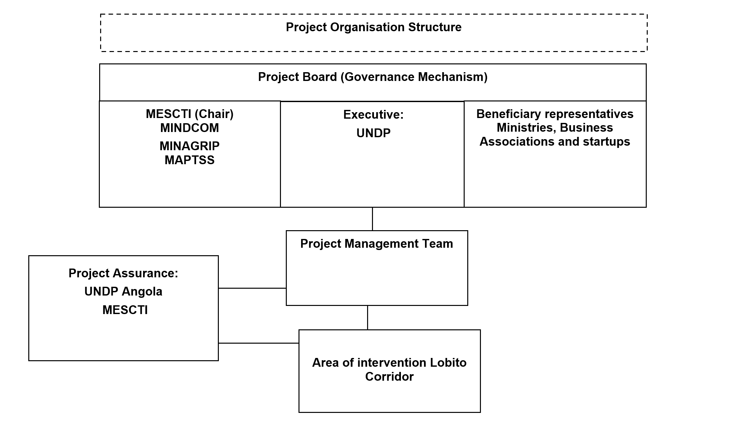
Implementation will follow four phases. Phase 1 (Months 1–2) will focus on project inception, site selection in Benguela, baseline data collection, and finalization of procurement and training curricula. Phase 2 (Months 3–7) will deploy equipment and satellite services, train extension agents and technicians, and roll out training programmes for youth and women, supported by field demonstrations. Phase 3 (Months 5–10) will support youth-led enterprises through micro-grants, mentorship, business formalization, and digital platform integration to strengthen market access and traceability. Phase 4 (Months 10–12) will consolidate results, conduct the endline evaluation, produce learning and policy products, and develop a scale-up roadmap. UNDP will submit the Final Project Report within three (3) months after project completion and the Final Financial Report within twelve (12) months following the conclusion of the project, in accordance with JSB requirements.
UNDP will manage procurement through an approved plan initiated early to mitigate customs delays, prioritizing vendor-backed solutions that include training, maintenance, and after-sales support. UNDP will proactively seek opportunities to engage Japanese technologies and/or Japanese companies during implementation, where appropriate and feasible, through technical collaboration and piloting arrangements that support project outcomes. Micro-grants will be awarded through transparent selection processes and disbursed against clearly defined milestones
Based on Country Office capacity, a fit-for-purpose Monitoring, Evaluation, and Learning (MEL) system will track progress against agreed targets. Baseline data collection, quarterly monitoring, and an end-of-project review will support adaptive management, accountability, and evidence-based learning, with regular reporting to the Project Steering Committee (PSC) and the donor...

UNDP publishes its project information (indicators, baselines, targets and results) to meet the International Aid Transparency Initiative (IATI) standards. Make sure that indicators are S.M.A.R.T. (Specific, Measurable, Attainable, Relevant and Time-bound), provide accurate baselines and targets underpinned by reliable evidence and data, and avoid acronyms so that external audience clearly understand the results of the project.
PLANAGRÃO- (National Promotion Plan for Grain Production), PLANAPECUÁRIA- (National Plan for the Promotion and Development of Livestock), PLANAPESCA-( The National Fisheries Promotion Plan), and PRODESI (Production Support, Export Diversification and Import Substitution Program).

